B.M.S COLLEGE OF ENGINEERING BENGALURU
Autonomous Institute, Affiliated to VTU



AAT Report on

Design and verification of
Digital circuits using Verilog

Submitted in partial fulfilment of AAT
for the course on
Advanced Digital Logic Design

By,
Akshaya Tunga K
1BM24EC009

To
Dr Ajay Kumar J
Assistant Professor

Department of electronics and communication
B.M.S College of Engineering
Bull Temple Road, Basavanagudi, Bangalore 560 019
2025-2026

Table of Contents
Sl. No. | Title | Page no.
 | Arithmetic Logic Unit (ALU) | 1-2
 | Comparator | 3-4
 | 4-Bit Parity Generator and Checker | 5-6
 | 4-Bit Barrel Shifter | 7-8
 | Timer Module | 9-11
 | Ring Counter | 12-13
 | Johnson Counter | 14-15
 | Synchronous and Asynchronous Counters | 16-21
 | Shift Register | 22-23
 | Divide-by-N Counter | 24-25
 | Mealy and Moore FSMs | 26-27
 | Random Sequence Generator | 27-28

Arithmetic Logic Unit (ALU)
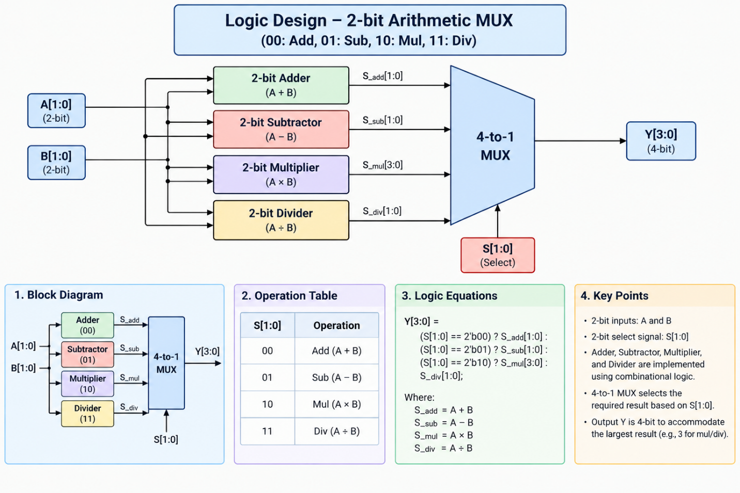
An Arithmetic Logic Unit (ALU) is a digital circuit that performs arithmetic and logical operations on binary data. It is an important part of the CPU (Central Processing Unit).
In this project, the ALU performs four arithmetic operations on two 2-bit inputs, \(A\) and \(B\).
- Addition (00): Adds A and B.
- Subtraction (01): Subtracts B from A.
- Multiplication (10): Multiplies A and B.
- Division (11): Divides A by B.
The select lines (S1, S0) determine which operation is performed. The results are connected to a multiplexer (MUX), which selects the required output.

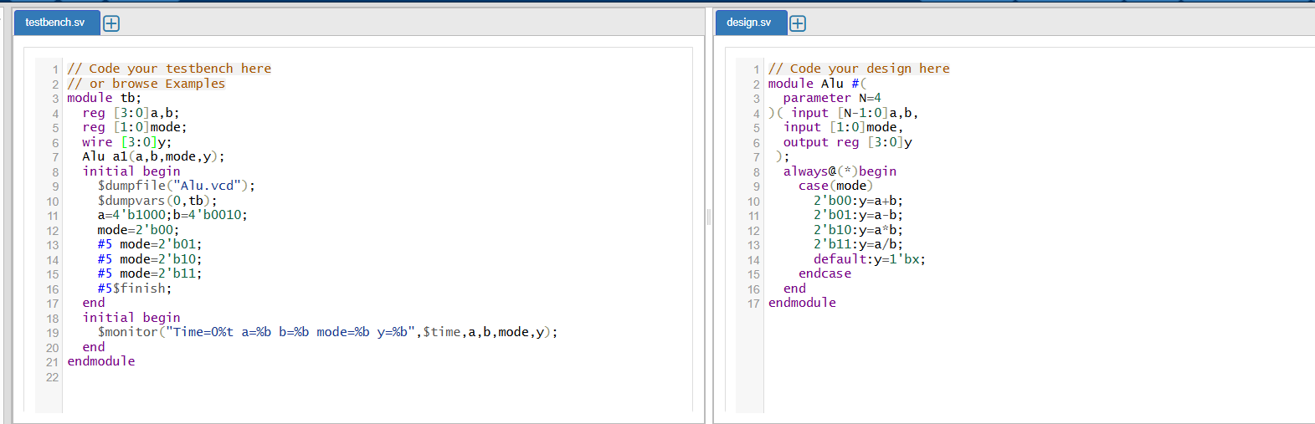
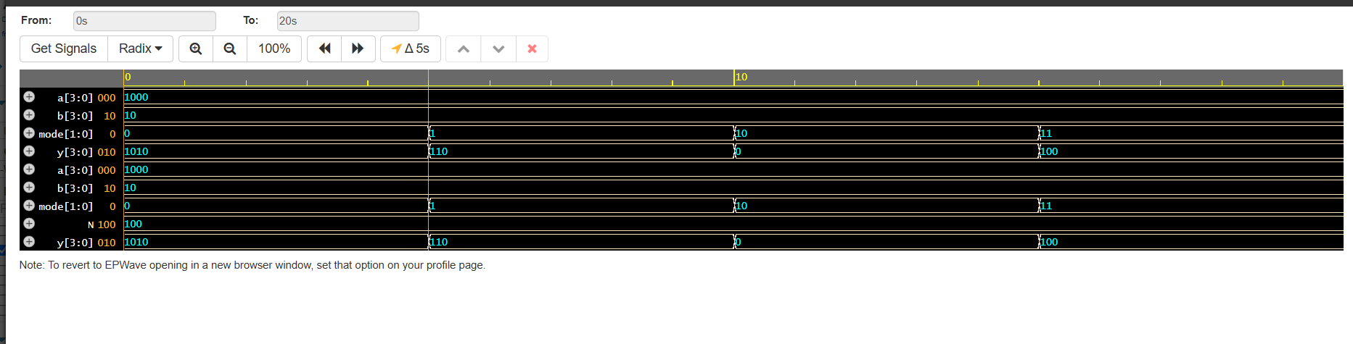

Above represents the code implemented on the EDA platform and the waveform as provided at the output.

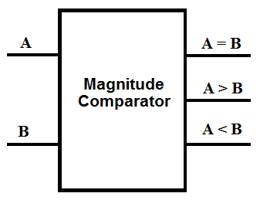
Comparator

Comparator Theory
- A comparator is a combinational logic circuit used to compare two binary numbers.
- It takes two inputs, A and B.
- It produces three outputs:
  - A > B: A is greater than B.
  - A < B: A is less than B.
  - A = B: A is equal to B.
- Only one output is HIGH at a time for valid binary inputs.
- Comparators are used in ALUs, digital systems, and control circuits.

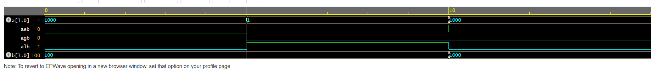
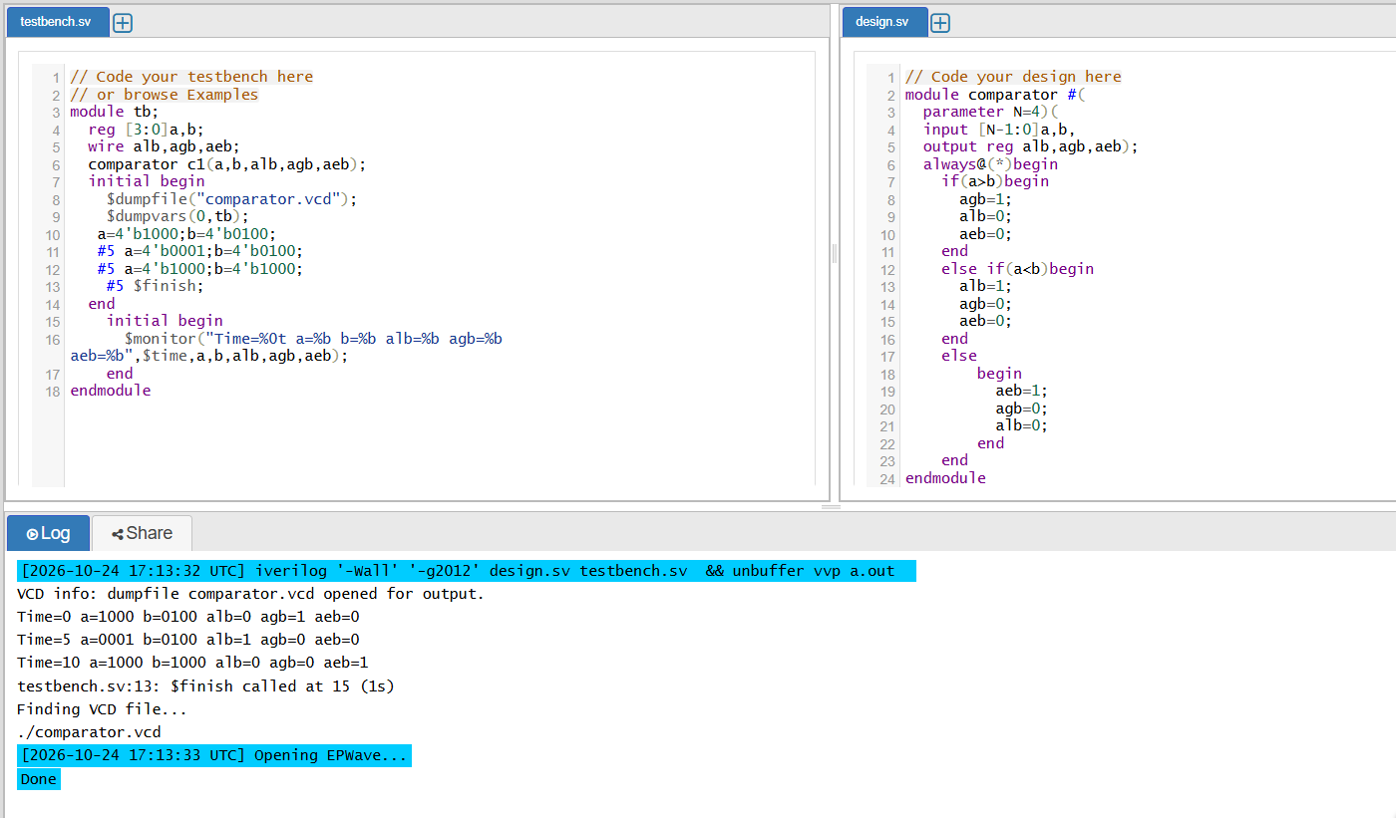

The above shows the code implemented on the EDA platform and the output waveform.

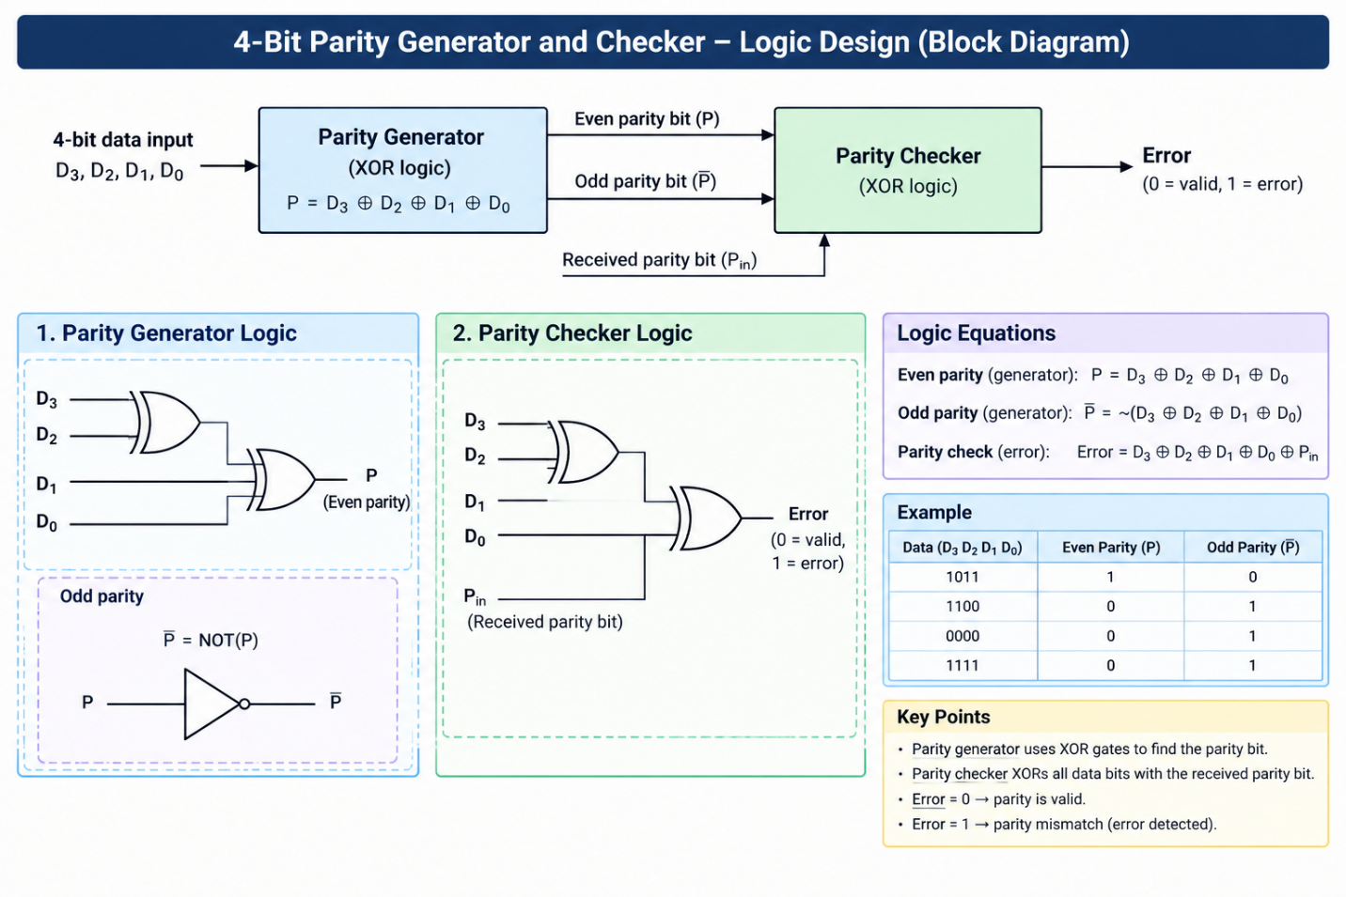
4-Bit Parity Generator and Checker

4-Bit Parity Generator and Checker
- Generates even or odd parity bits for 4-bit data using XOR gates.
- The parity generator adds a parity bit to the data.
- The checker verifies the received data and parity bit.
- It detects errors when the parity does not match.
- Used in digital communication and error detection.

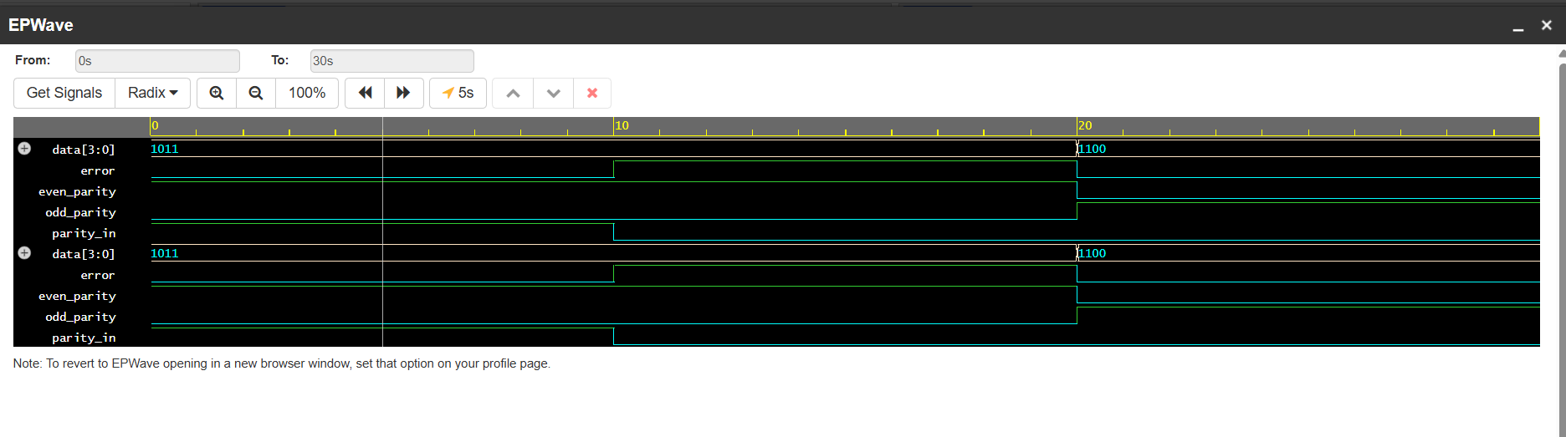
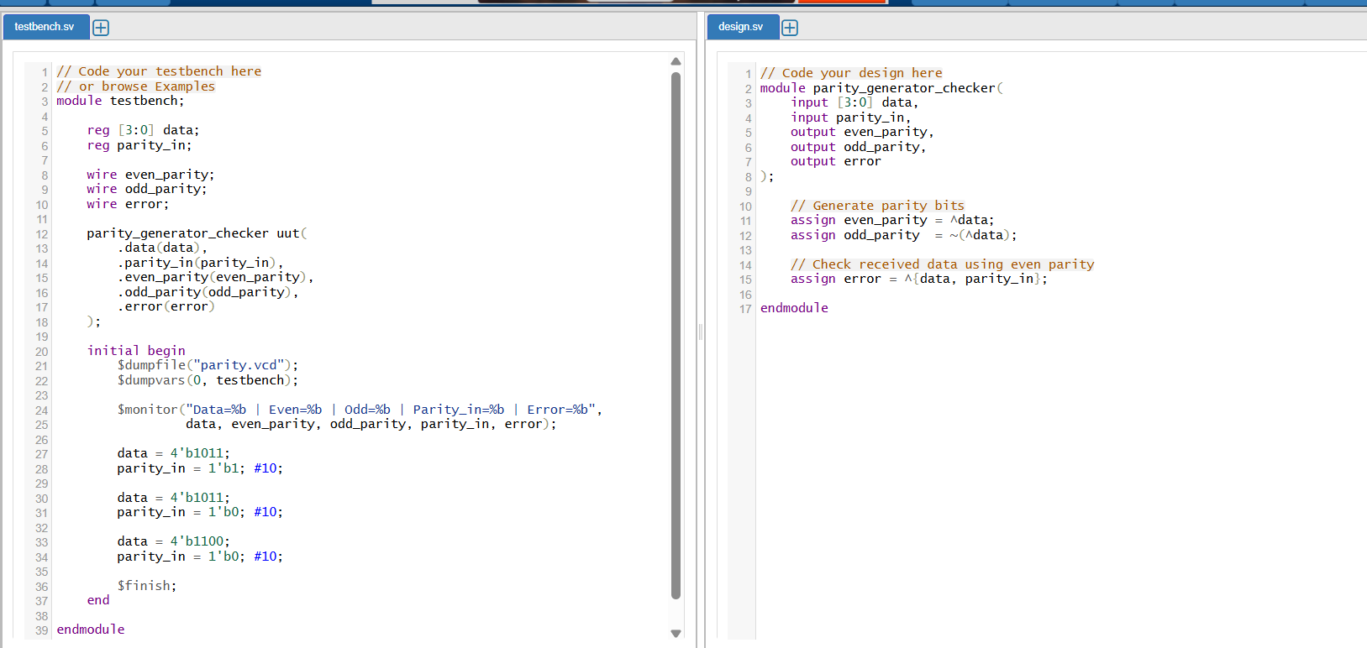

The above shows the code implemented on the EDA platform and the output waveform

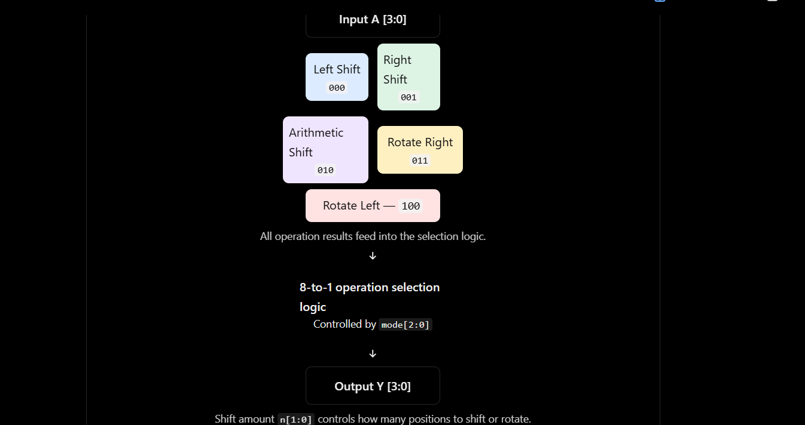
4-Bit Barrel Shifter

4-Bit Barrel Shifter
- Shifts or rotates 4-bit binary data by a specified number of positions.
- Performs left shift and right shift operations.
- Can also perform arithmetic shifts and rotations.
- The select lines determine the operation.
- Used in ALUs and processors.

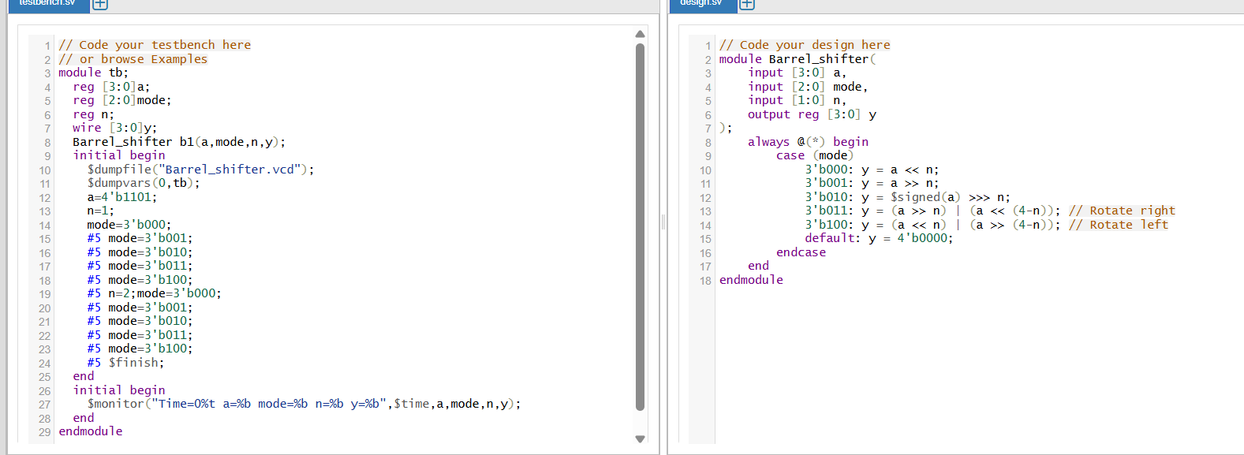
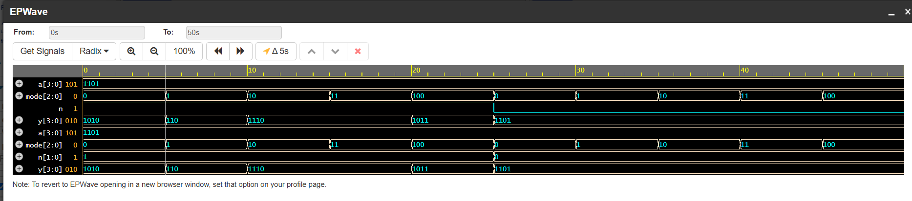

The above shows the code implemented on the EDA platform and the output waveform.

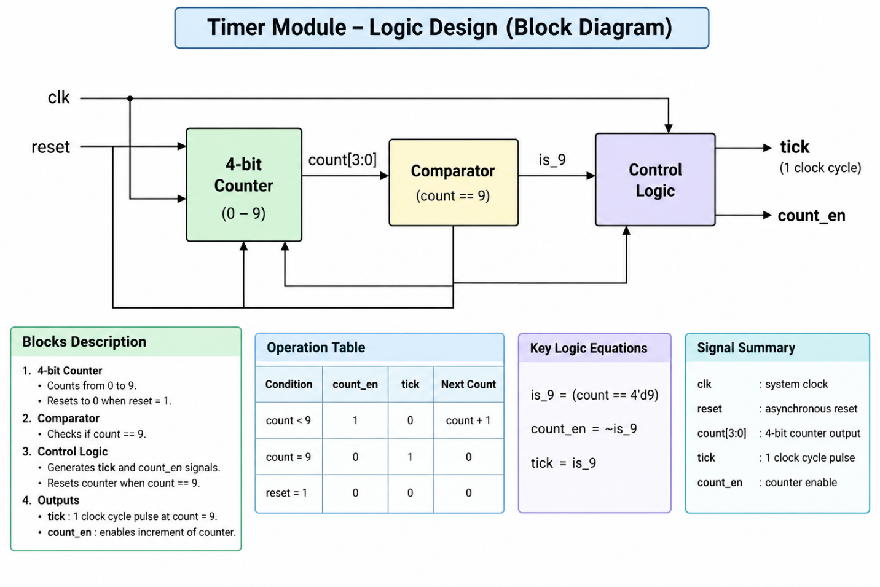
Timer Module

Timer Module
- Counts clock pulses to measure a time interval.
- Uses a counter and comparator to check the target count.
- Generates an output signal when the required count is reached.
- Reset logic restarts the count.
- Used in digital clocks and embedded systems.

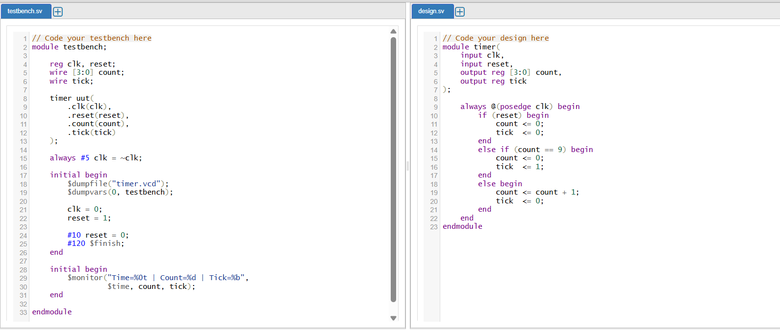
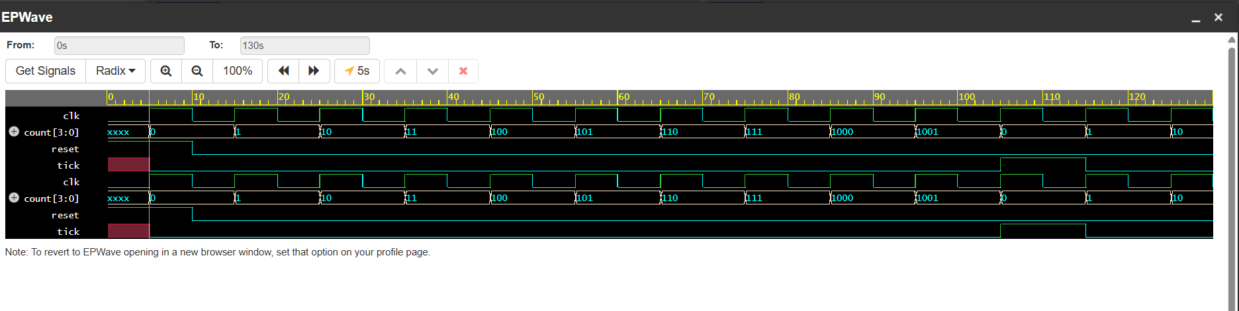

The above shows the code implemented on the EDA platform and the output waveform.

Ring Counter
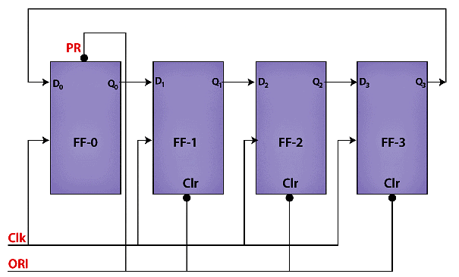

Ring Counter
- Consists of flip-flops connected as a shift register.
- The last flip-flop output is fed back to the first.
- A single 1 circulates through the register when initialized correctly.
- An n-bit ring counter typically has n states.
- Used in sequence generation and control circuits.

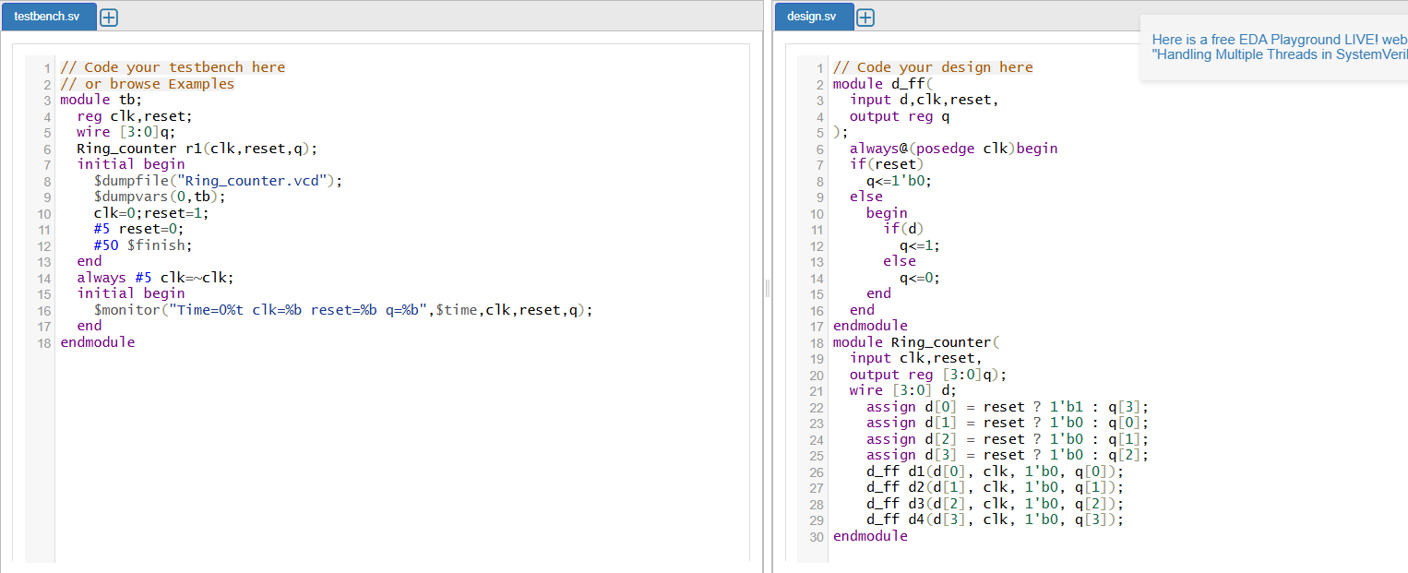

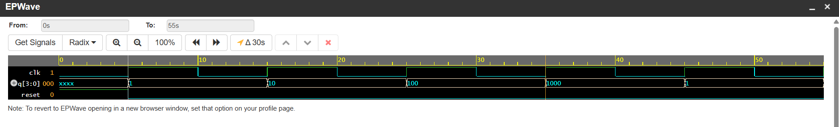
The above shows the code implemented on the EDA platform and the output waveform.

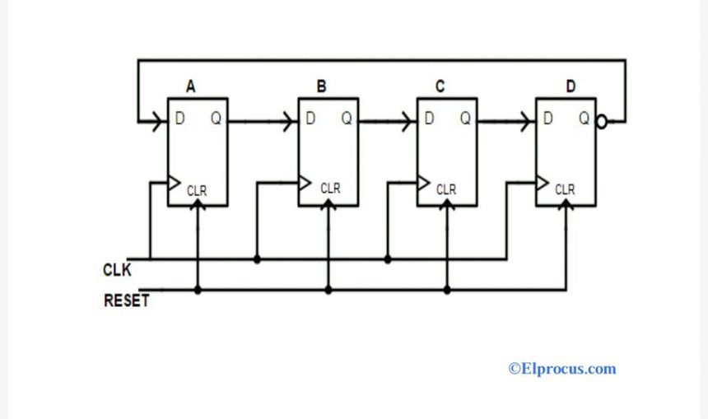
Johnson Counter

Johnson Counter
- Consists of flip-flops connected in a shift-register arrangement.
- The complemented output of the last flip-flop feeds the first.
- An n-bit Johnson counter can generate up to 2n states.
- Requires a suitable initial or reset state.
- Used in timing and sequence-generation circuits.

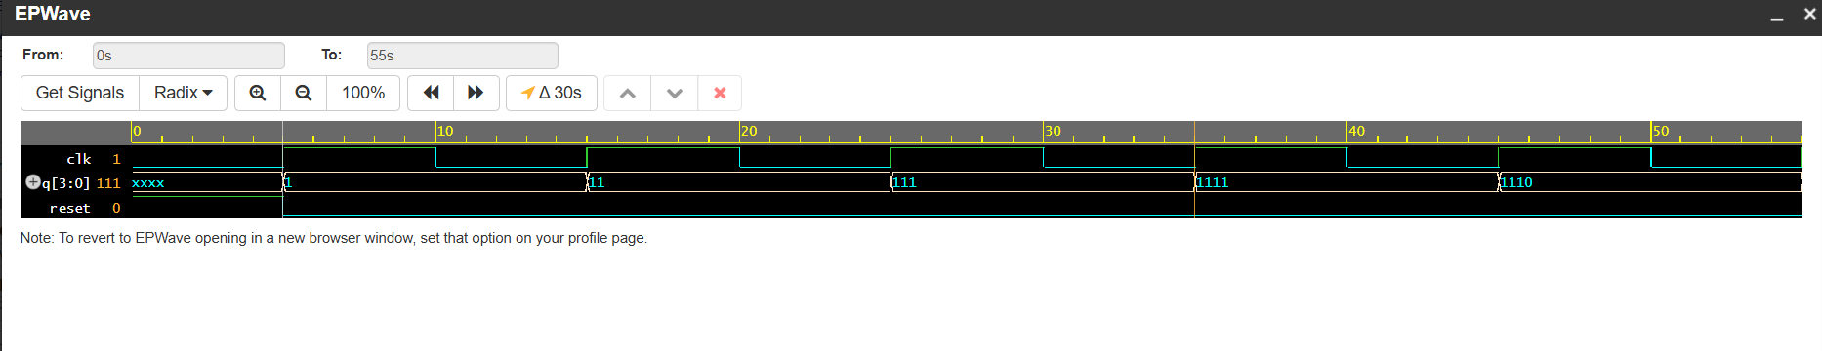
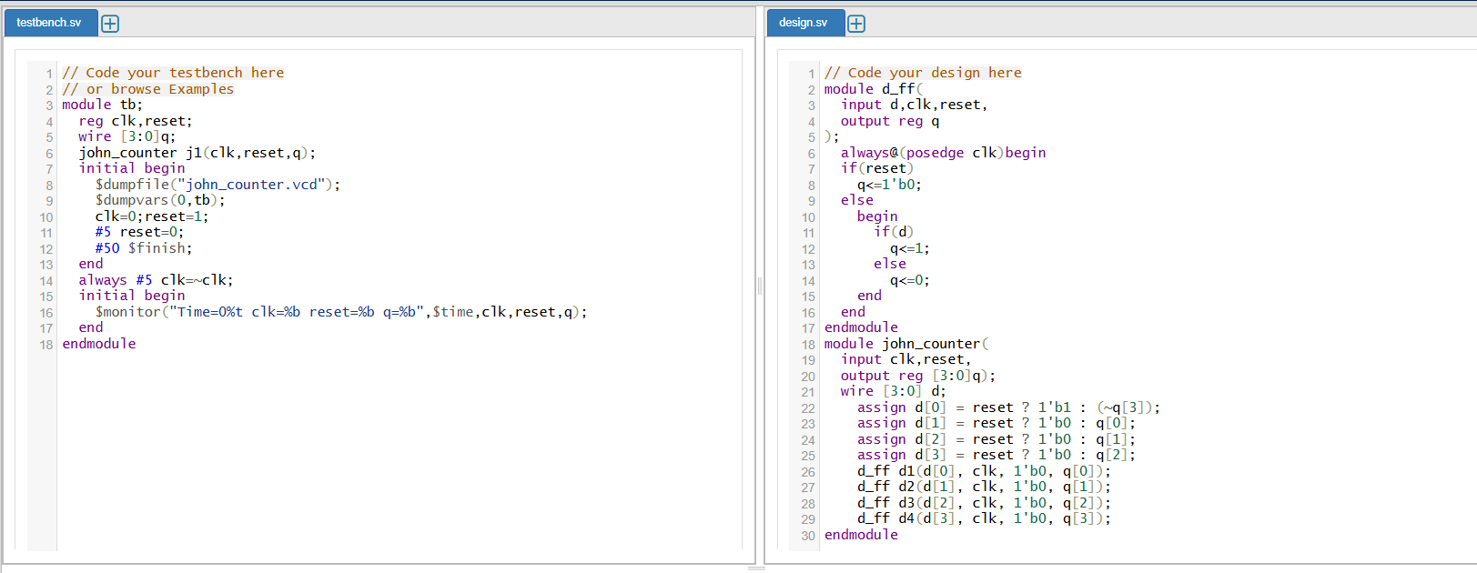

The above shows the code implemented on the EDA platform and the output waveform.

Synchronous and Asynchronous Counters

Synchronous counter
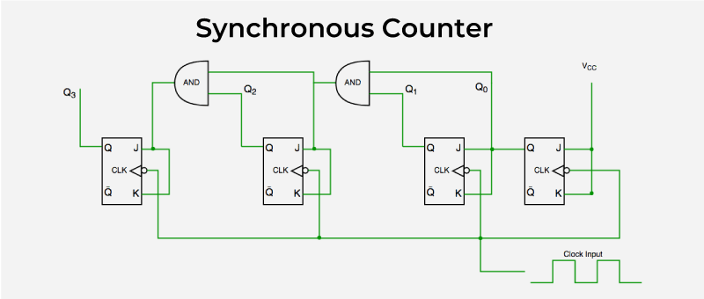

Synchronous Counter
- A synchronous counter is a digital circuit that counts clock pulses using flip-flops.
- All flip-flops receive the same clock signal.
- All flip-flops change their states simultaneously at the active clock edge.
- It operates at higher speeds because propagation delays do not accumulate through the clock chain.
- It is used in high-speed digital systems and processors.

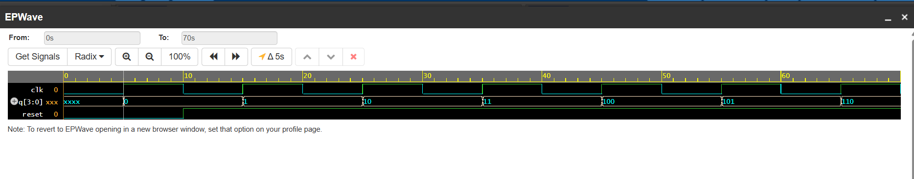
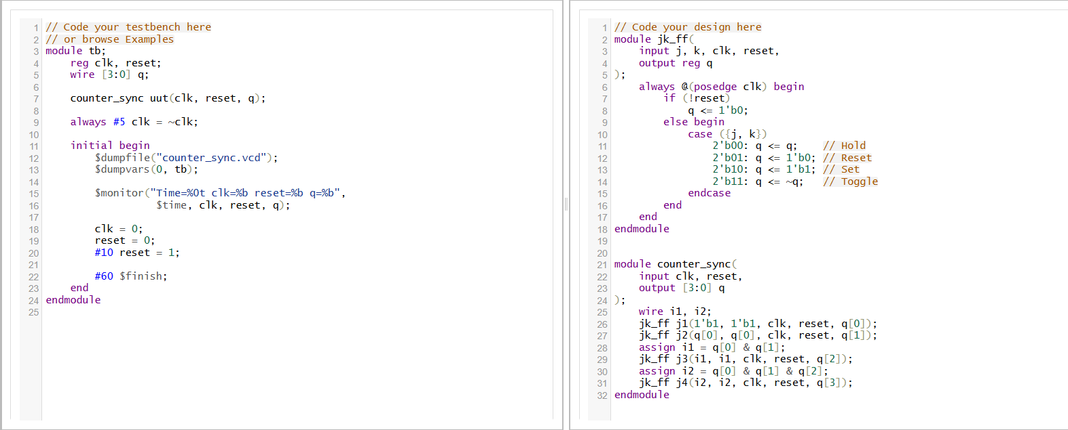

The above shows the code implemented on the EDA platform and the output waveform.

Asynchronous Counter

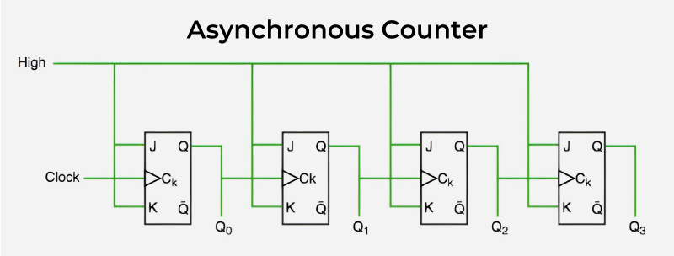

Asynchronous Counter
- An asynchronous counter is a digital circuit that counts clock pulses using flip-flops.
- Only the first flip-flop receives the external clock signal.
- The output of one flip-flop acts as the clock for the next flip-flop.
- It is slower because propagation delays accumulate from one flip-flop to another.
- It is used in frequency dividers and simple counting circuits.

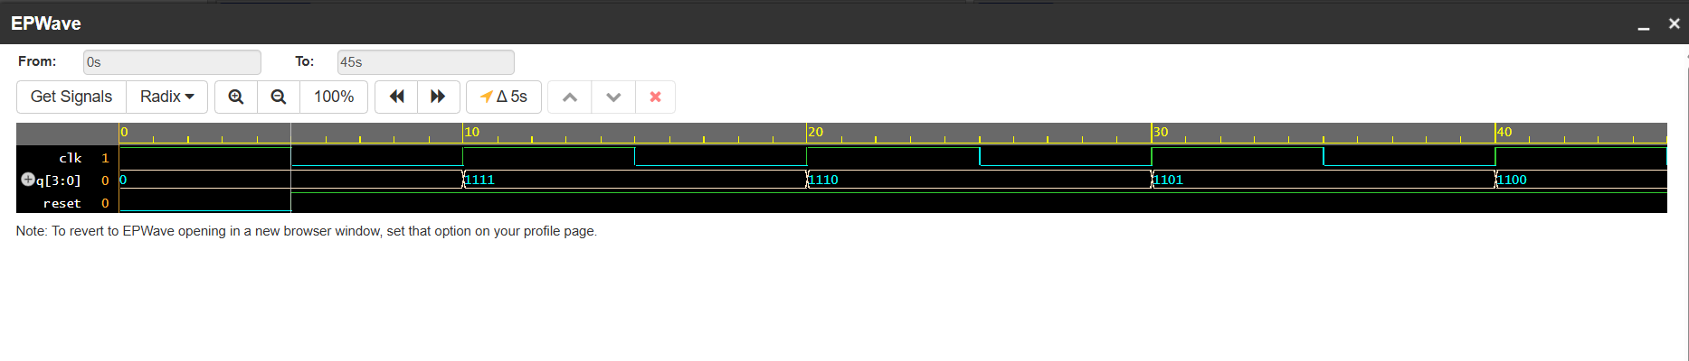
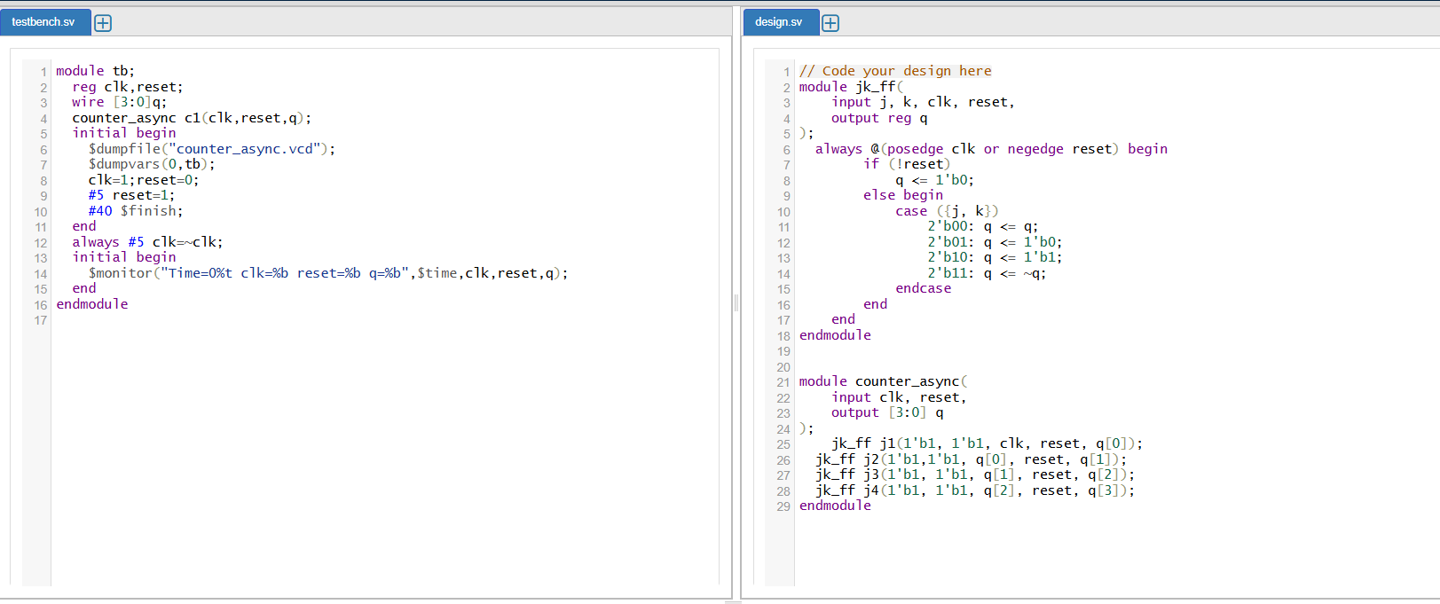

The above shows the code implemented on the EDA platform and the output waveform.

Shift Register
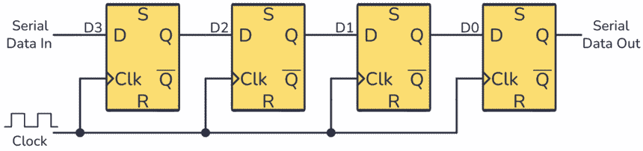

Shift Register

- A shift register stores binary data using flip-flops.
- Data shifts one bit position at each active clock edge.
- Types include SISO, SIPO, PISO, and PIPO.
- It supports serial and parallel data transfer.
- Used in data storage and communication systems.

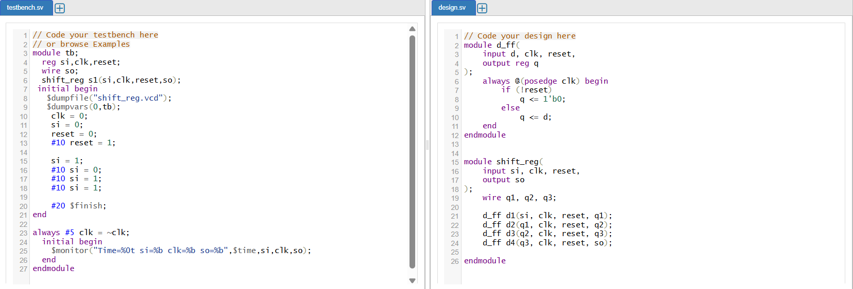
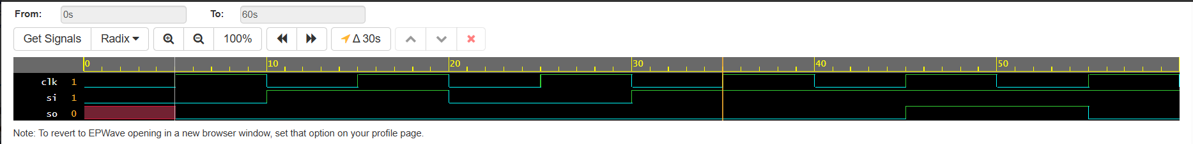

The above shows the code implemented on the EDA platform and the output waveform.

Divide-by-N Counter

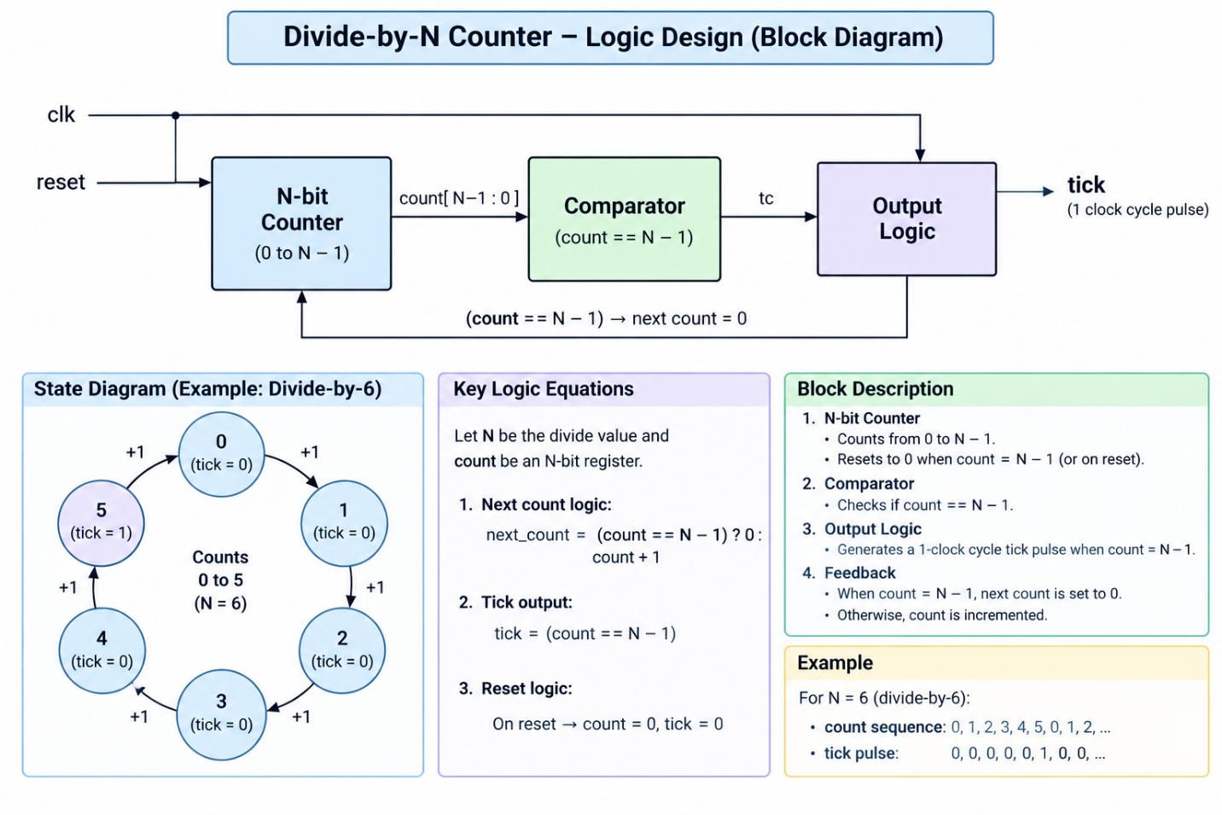

Divide-by-N Counter
- Counts clock pulses from 0 to N−1 and then repeats.
- Resets the count after reaching the terminal value.
- Generates one terminal-count pulse every N clock cycles.
- Divides the pulse repetition frequency by N.
- Used in clock division and timing circuits.

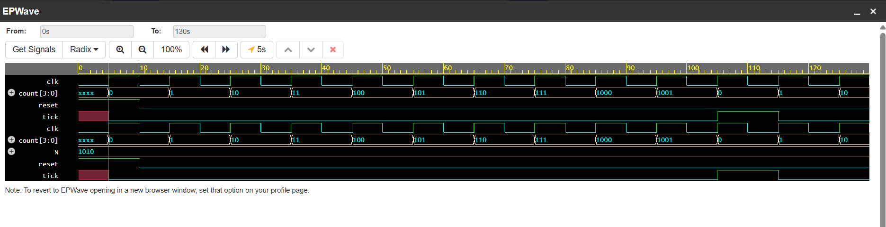
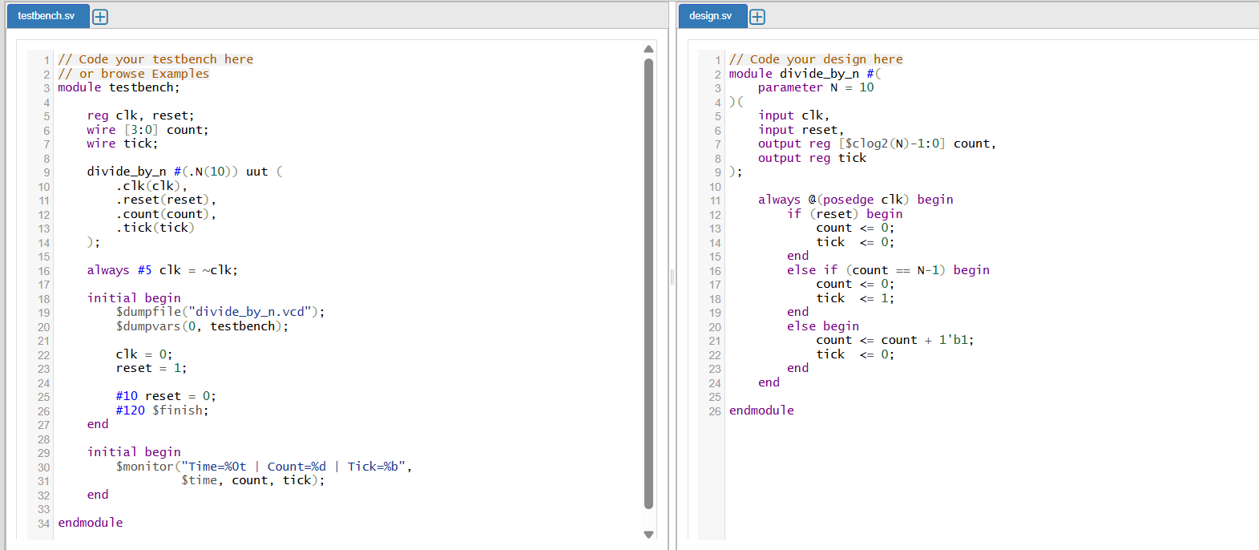

The above shows the code implemented on the EDA platform and the output waveform.

Mealy and Moore FSMs
Mealy Model
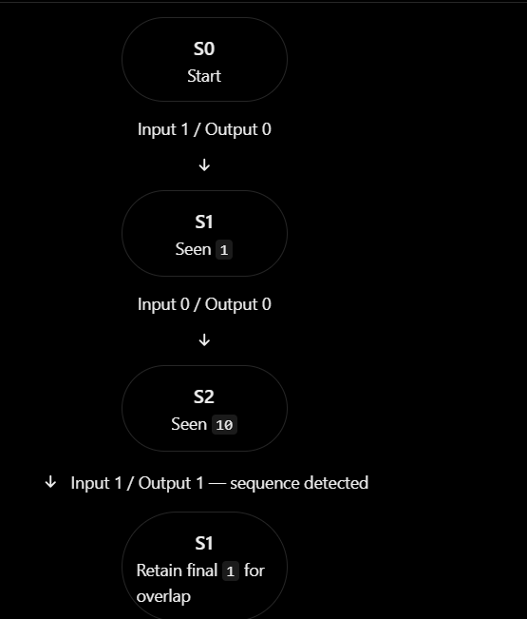

Mealy FSM
- Output depends on the current state and input.
- Output can change when the input changes.
- Usually requires fewer states than an equivalent Moore design.
- Output logic depends on both state and input.
- Example: Mealy sequence detector for 101.

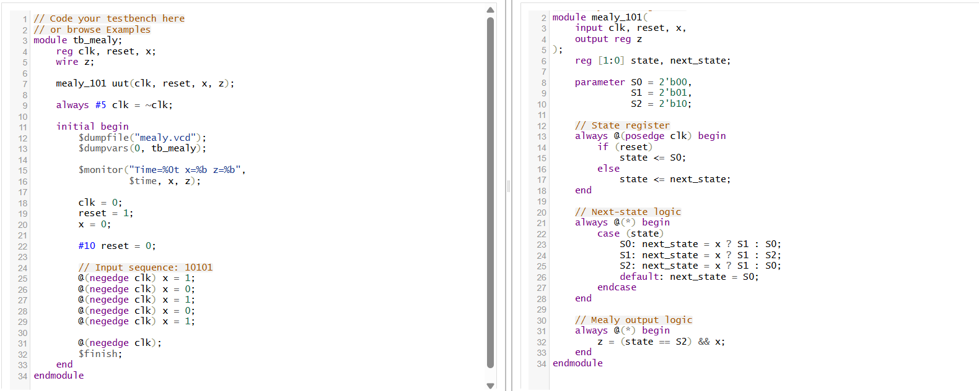
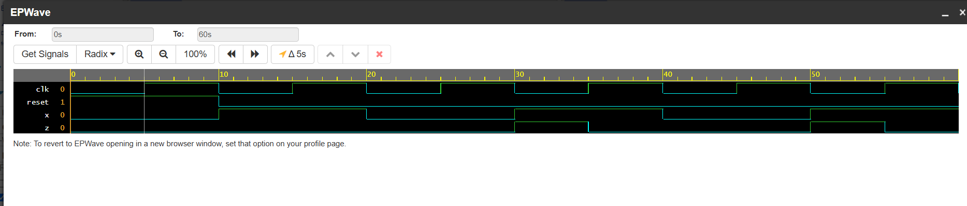

The above shows the code implemented on the EDA platform and the output waveform

Moor model
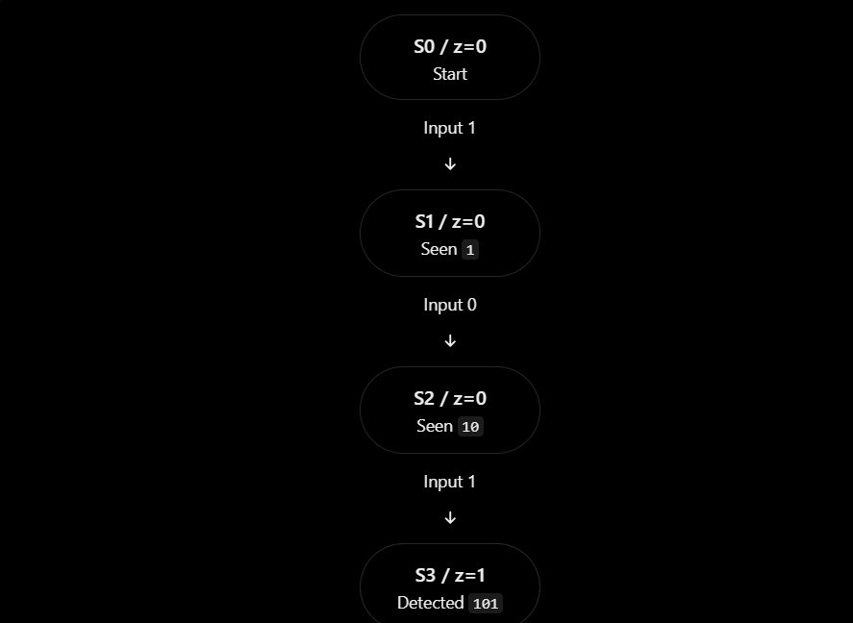

Moore FSM
- Output depends only on the current state.
- Output changes when the state changes.
- Outputs are generally easier to synchronize with the clock.
- May require more states than an equivalent Mealy design.
- Example: Moore sequence detector for 101.

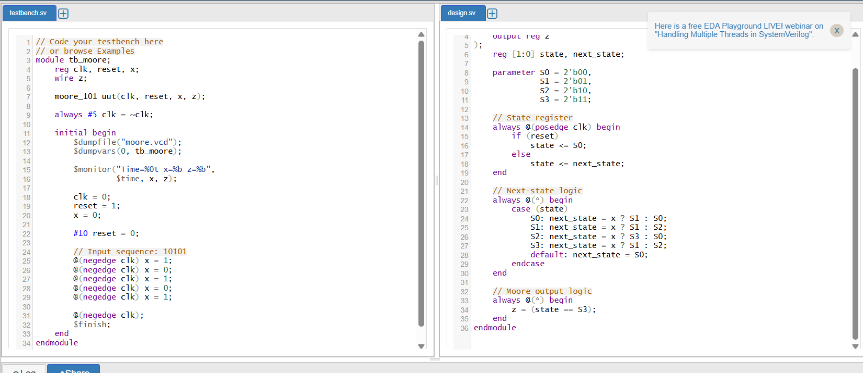
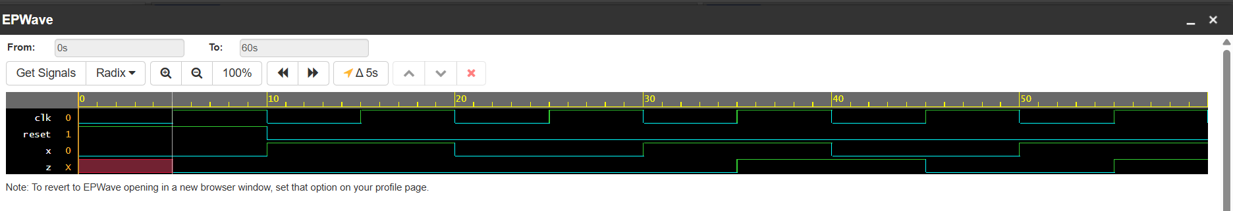

The above shows the code implemented on the EDA platform and the output waveform.

Random Sequence Generator
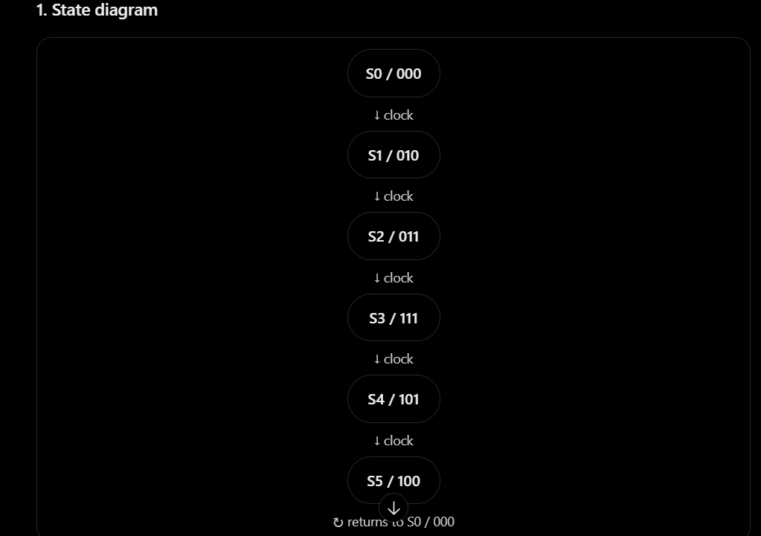

Random Sequence Generator
- Generates a pseudo-random sequence of binary values.
- Can be implemented using a Linear Feedback Shift Register (LFSR).
- Uses flip-flops and XOR feedback logic.
- The sequence repeats after a certain number of clock cycles.
- Used in digital testing and communication systems.

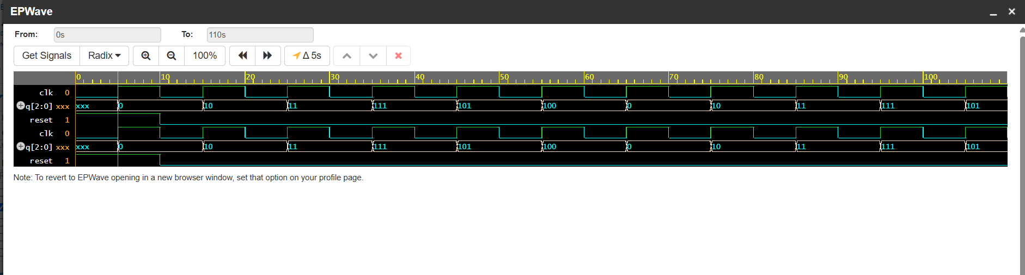
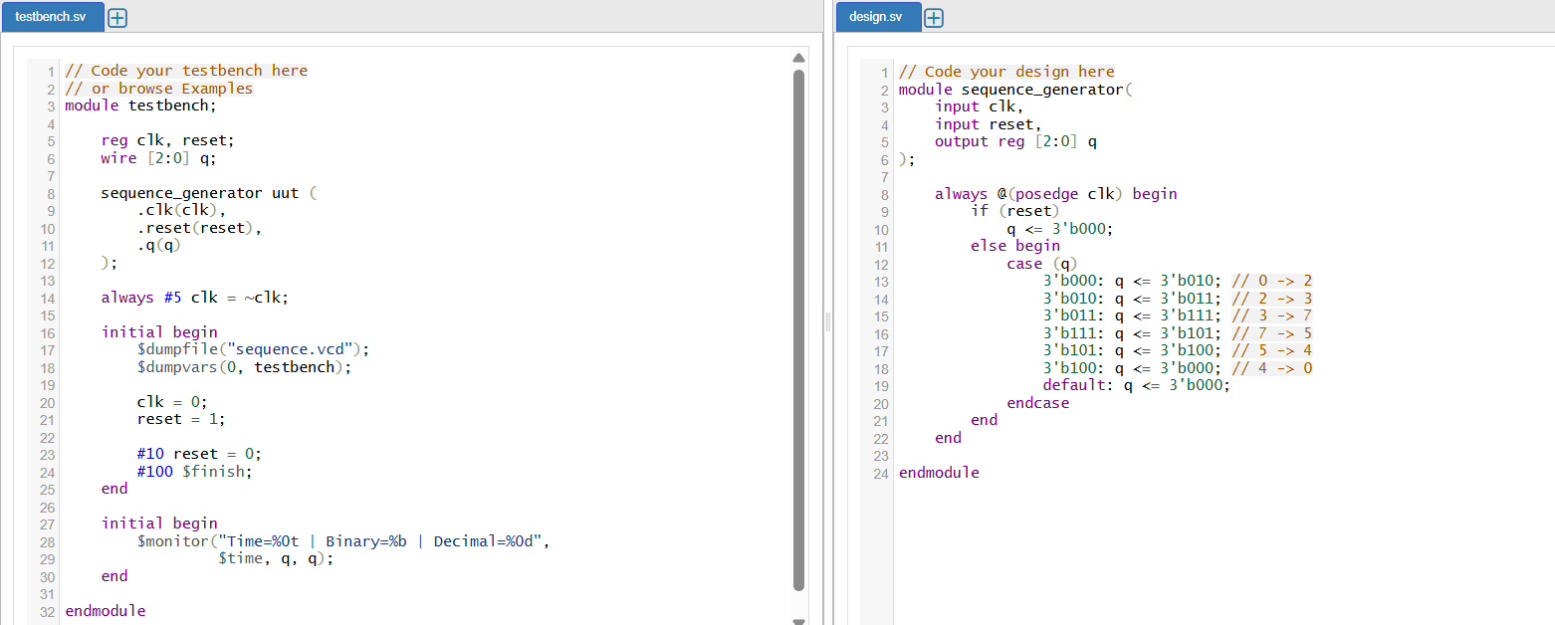

The above shows the code implemented on the EDA platform and the output waveform.

